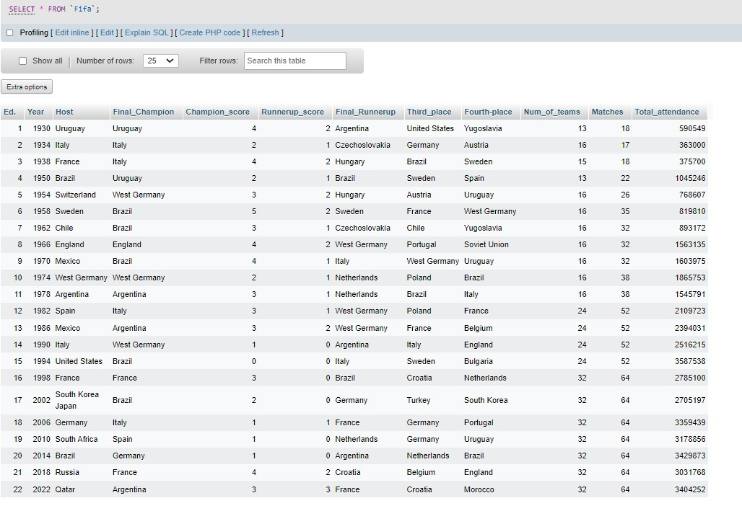**SQL QUERIES**

1. **Count the number of distinct host**

SELECT COUNT(DISTINCT Host) AS Num_of_Hosts, Host

FROM Fifa

GROUP BY Host;

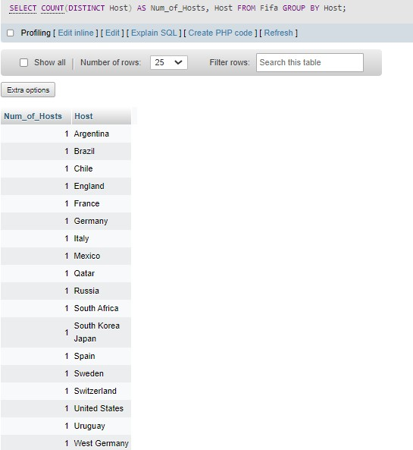

1. **Retieve the hosts corresponding to the years**

SELECT Year, Host

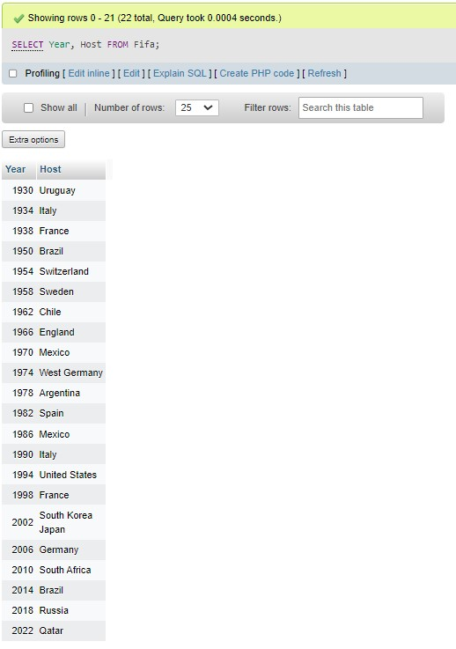FROM Fifa;

1. **Retrieve all columns where the Champion is brazil**

SELECT *

FROM Fifa

WHERE Final_Champion = 'Brazil';

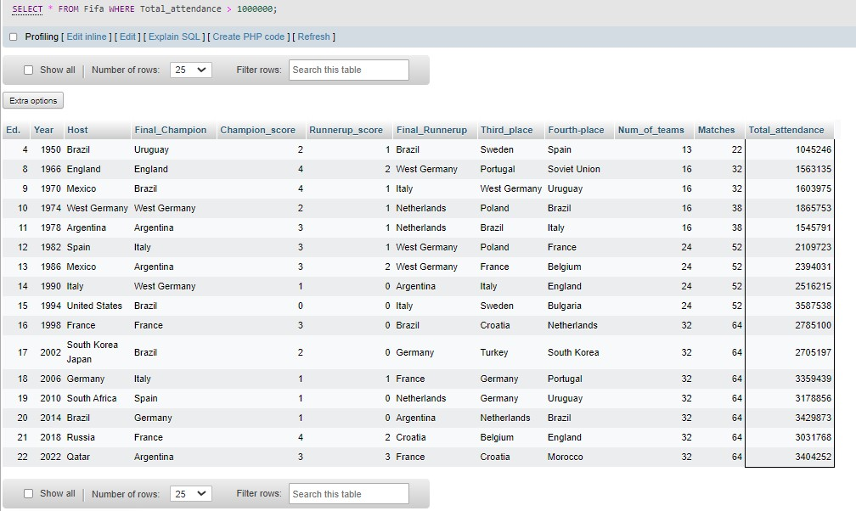

1. **Retrive columns where total attendance > 1000000**

SELECT *

FROM Fifa

WHERE Total_attendance > 50000;

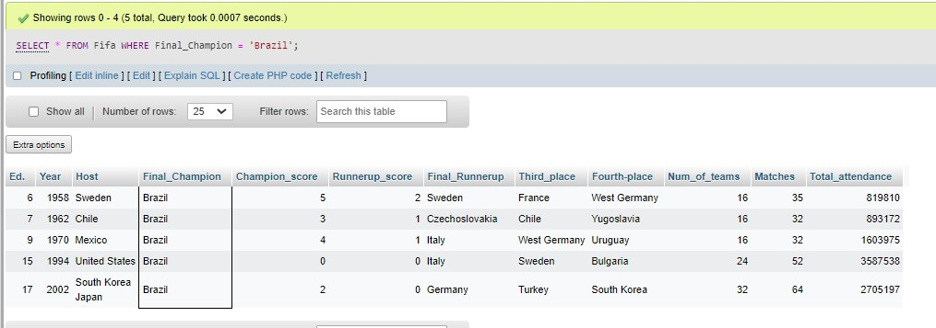

1. **Retrive the year and the no. of teams**

SELECT Year,

Num_of_teams

FROM Fifa;

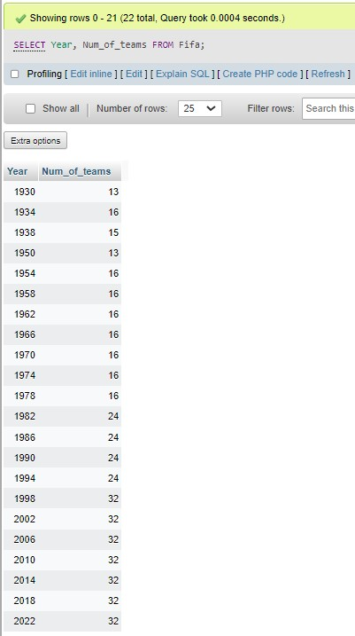

1. **Team with the highest number of championships:**

SELECT Final_Champion, COUNT(*) AS Num_of_Championships

FROM Fifa

GROUP BY Final_Champion

ORDER BY Num_of_Championships DESC

LIMIT 1;

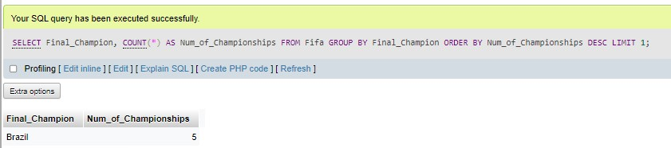

1. **Retrieve final champion and runner up**

SELECT Year, Final_Champion, Final_Runnerup

FROM Fifa;

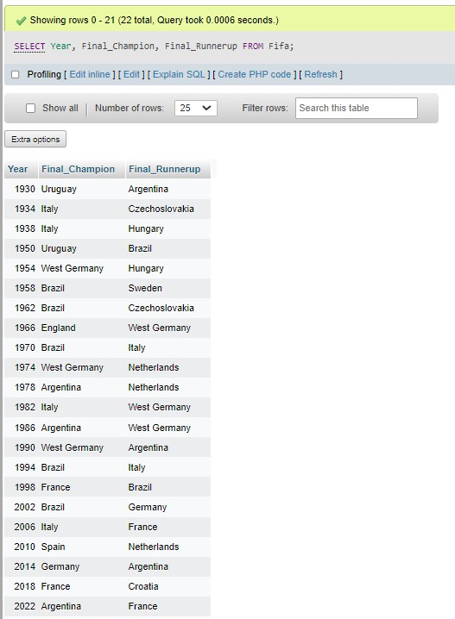

1. **Retrieve the year and host of the FIFA edition with the highest total attendance:**

SELECT Year, Host, Total_attendance

FROM Fifa

WHERE Total_attendance = (

SELECT MAX(Total_attendance)

FROM fifa_table

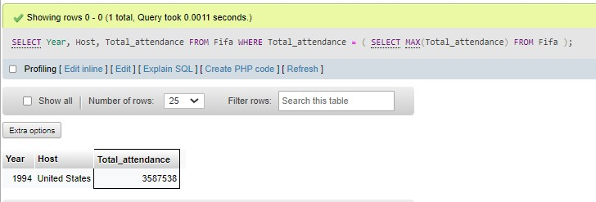);

1. **Retrieve the year and host of FIFA editions that had more than 32 teams:**

SELECT Year, Host

FROM Fifa

WHERE Num_of_teams > 20;

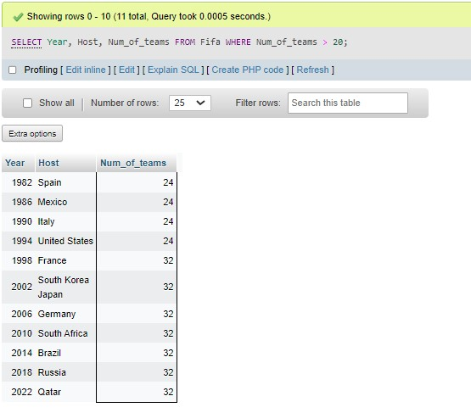

1. **Retrieve the year, host, and the number of matches for FIFA editions that had a total attendance greater than the average attendance:**

SELECT Year, Host, Matches

FROM Fifa

WHERE Total_attendance > (

SELECT AVG(Total_attendance)

FROM Fifa

);

